Letter from Hogwarts
Description:
I got the letter from hogwarts but it was password encrypted help me to find, lets try until we get the password the password for the pdf. In that pdf u can get the flag.
-- First I used pdfcrack
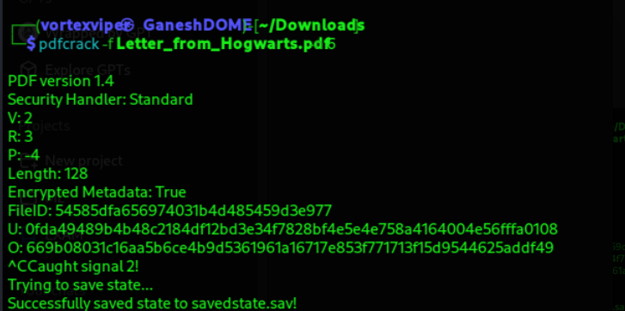
Encryption version(v) and revision( r), permission flags p and length--128
Masks which I have used but no use
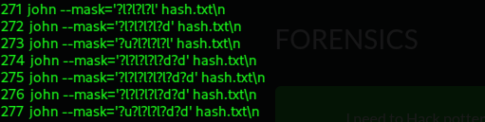

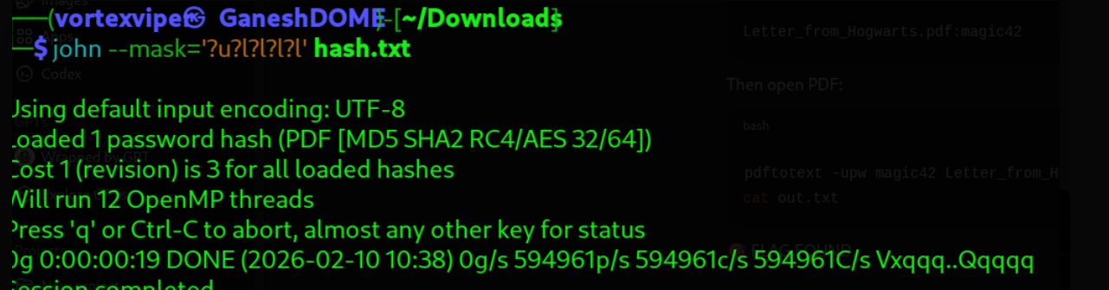

Nothing added to hash
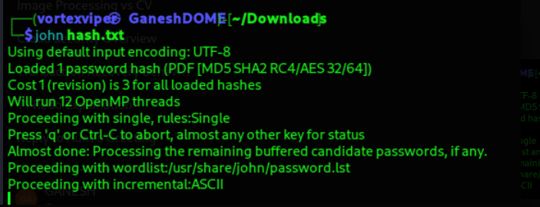

After loading the password I used qpdf to decrypt but theres no password loaded!

I loaded one wordlist(rockyou) which contain many cracked passwords and I check all those with john then I have got the flag